LAB 1

Basic algorithms and their complexities

1.1 algorithm for GCD  
  
#include <iostream>

// Function to compute GCD using the Euclidean algorithm

int gcd(int a, int b) {

while (b != 0) {

int temp = b;

b = a % b; // Update b to be the remainder of a divided by b

a = temp; // Update a to be the previous value of b

}

return a; // When b is 0, a contains the GCD

}

int main() {

int num1, num2;

std::cout << "Enter two integers: ";

std::cin >> num1 >> num2;

int result = gcd(num1, num2);

std::cout << "GCD of " << num1 << " and " << num2 << " is: " << result << std::endl;

return 0;

}

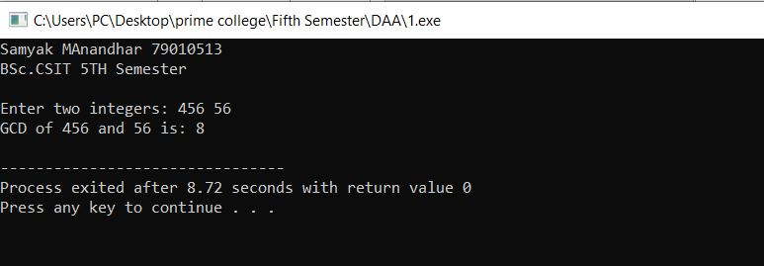

1.2 algorithm for Fibonacci